**UNIT I – Introduction to IT System**

**Notebook Theory + English Definition + WhatsApp Language Notes**

**1. INTERNET**

**Theory (Notebook Notes):**

The **Internet** is a worldwide system of interconnected computer networks that use the TCP/IP protocol to communicate. It allows users to access and exchange information globally. It connects millions of private, public, academic, business, and government networks. The Internet supports services such as email, file transfer, online education, web browsing, e-commerce, and social media.

It is one of the most important tools of the digital age and is used in almost every field including education, banking, healthcare, governance, and entertainment.

**Definition (English):**

**Internet** is a global network of computers that allows people to communicate and share information through websites, emails, social media, etc.

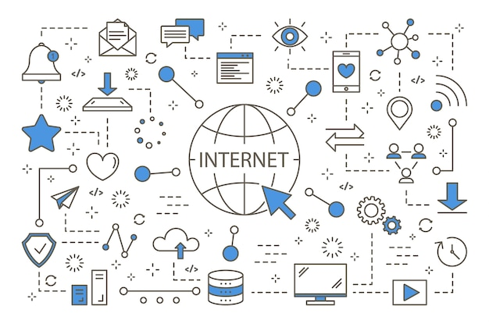

**WhatsApp Style Notes:**

Internet matlab duniya bhar ke computers ka ek joda hua network. Jiske through hum Google, YouTube, WhatsApp, banking, shopping sab kuch online karte hain. Har jagah use hota hai – school, hospital, sarkari kaam, sab mein.

**2. WEB BROWSER**

**Theory (Notebook Style):**

A **Web Browser** is a software application used to access and view websites on the Internet. It allows users to retrieve, present, and navigate information resources on the World Wide Web. Modern web browsers support text, images, videos, audio, and various online tools.

Popular browsers include:

* Google Chrome
* Mozilla Firefox
* Microsoft Edge
* Safari

Features of browsers:

* Address bar for URLs
* Tabs to open multiple pages
* Bookmarks to save websites
* Private browsing (Incognito mode)

**Definition (English):**

**Web Browser** is a software used to open and view websites on the Internet.

**WhatsApp Style Notes:**

Browser ek app hota hai jaise Chrome, jisse hum website open karte hain. Jaise Google open karna ho, toh browser chahiye. Isme tabs hote hain, history, download sab kuch milta hai.

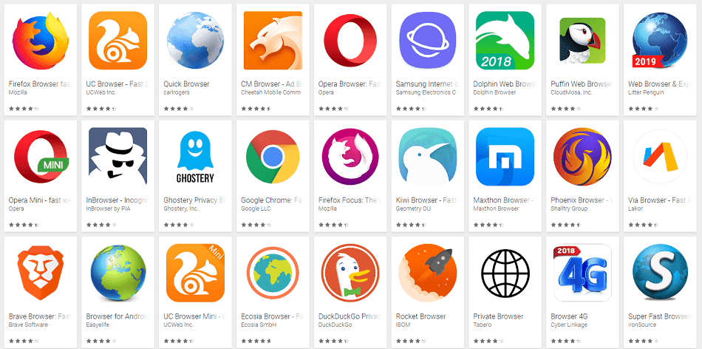

**3. SEARCH ENGINE**

**Theory (Notebook Style):**

A **Search Engine** is an online tool that helps users find information on the internet. It works by crawling and indexing websites and displaying the most relevant results based on the user's query.  
  
Examples of search engines:

* Google
* Bing
* Yahoo

Search engines rank pages using algorithms based on keywords, site popularity, content relevance, and user behavior.

**Definition (English):**

**Search Engine** is a website or tool that helps find other websites or information on the internet using keywords.

**WhatsApp Style Notes:**

Google jaisa search engine hota hai. Jab hum kuch search karte hain – like “best college in India” – toh Google uska answer dikhata hai. Ye keywords se kaam karta hai.

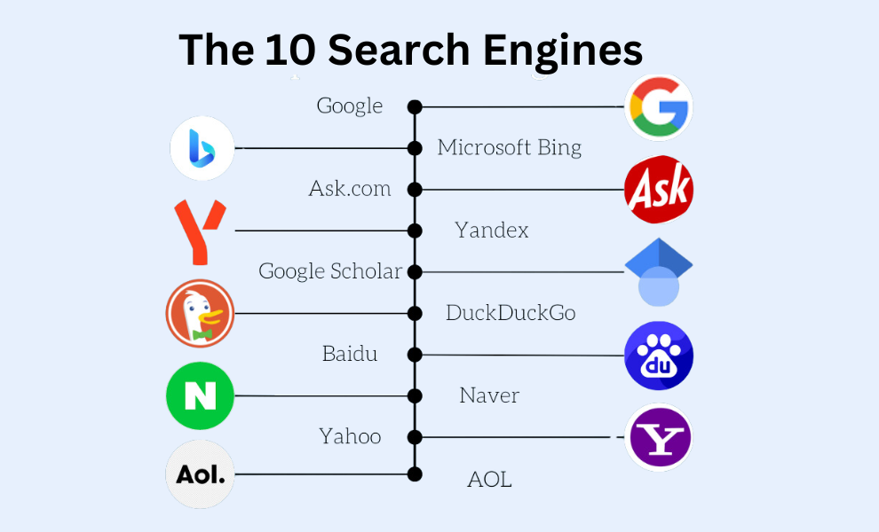

**4. DIGITAL INDIA PORTALS**

**Theory (Notebook Style):**

Digital India Portals are online platforms launched by the Government of India to offer public services electronically. These portals aim to promote digital literacy, reduce paperwork, increase transparency, and provide faster services to citizens.

**Popular National Portals:**

* **DigiLocker** – Store and download documents like Aadhaar, PAN, Marksheet
* **UMANG App** – Unified app for 100+ govt services
* **NSP** – National Scholarship Portal
* **e-Hospital** – Book appointments in govt hospitals

**State-Level Examples:**

* UP eDistrict
* Rajasthan Sampark
* TN eSevai
* Karnataka Bhoomi

**Definition (English):**

**Digital India Portals** are official government websites/apps that provide various public services online.

**WhatsApp Style Notes:**

Digital India ka matlab hai ki sarkari kaam ab online ho gaya hai.   
Jaise DigiLocker me apni mark sheet milegi,   
NSP se scholarship apply karoge,   
UMANG app se sarkari service use kar sakte ho.   
Line me lagne ki zarurat nahi.

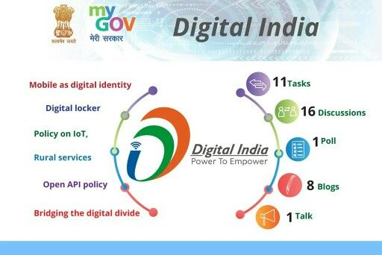

**5. COLLEGE PORTALS**

**Theory (Notebook Style):**

A **College Portal** is an online system provided by educational institutions to help students and faculty manage academic activities. These portals are accessible with login credentials and offer a range of features for better academic management.

**Common Features:**

* View attendance
* Check results and internal marks
* Download assignments and study material
* Submit assignments online
* Pay fees online
* Communication with faculty

**Definition (English):**

**College Portal** is an online platform where students can check attendance, results, assignments, and communicate with the institution.

• CPU

• Memory (RAM, ROM)

• Display

• Keyboard, Mouse

• HDD and Peripheral Devices

• OS Installation (Linux and MS Windows)

• Unix Shell and Commands

• vi editor

(UNIT I – Computer Hardware Components)

1. CPU (Central Processing Unit)  
 **English Long Definition:**

The **Central Processing Unit (CPU)** is the primary component of a computer that processes instructions. It consists of the Arithmetic Logic Unit (ALU), which performs mathematical and logical operations, and the Control Unit, which directs the execution of instructions by coordinating other parts of the computer. CPU speed determines how fast a computer can perform tasks.

**Simple English Definition:**

CPU is the brain of the computer that processes instructions and controls other parts.

**Hinglish Explanation:**

CPU computer ka main hissa hota hai, jise hum computer ka “dimaag” kehte hain. Ye sari instructions ko samajhta hai aur unpe kaam karta hai. CPU do important parts se bana hota hai:

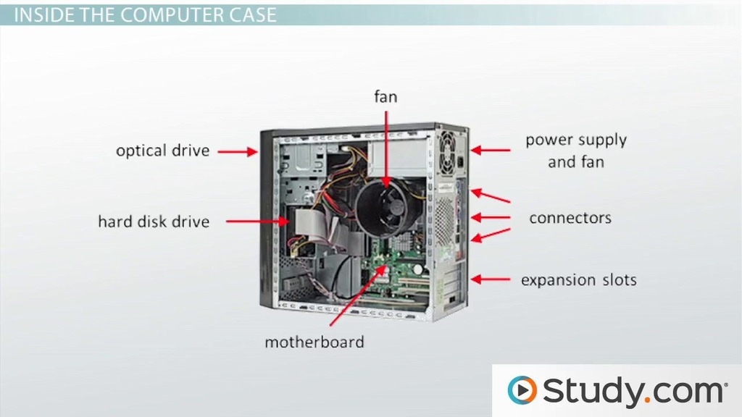

* **ALU (Arithmetic Logic Unit):** Ye calculations karta hai, jaise add, subtract, compare, etc.
* **Control Unit:** Ye poore computer ko instructions deta hai ki kya karna hai.

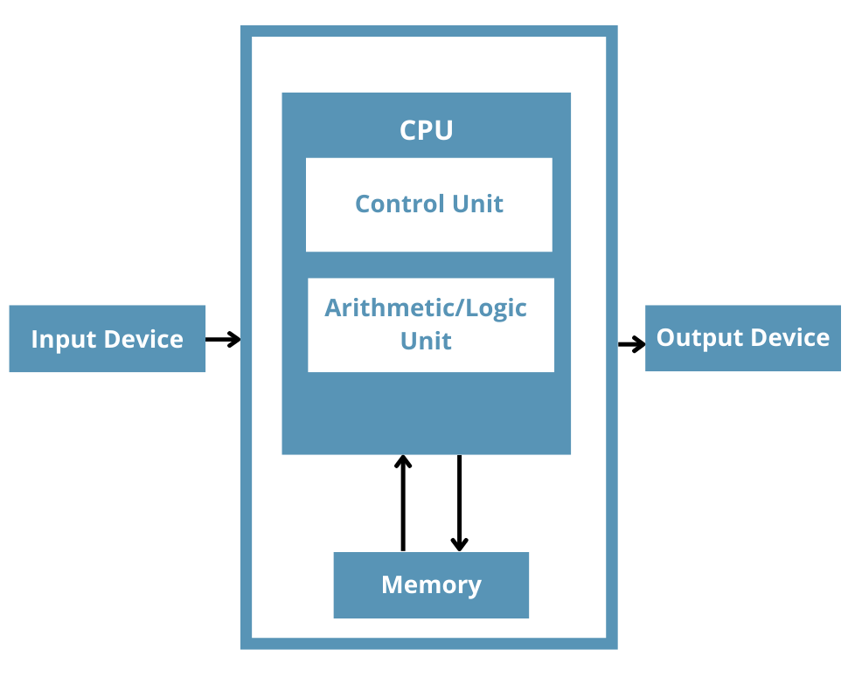

**2. Memory: RAM and ROM**

**Hinglish Explanation:**

**Memory do types ki hoti hai:**

* **RAM (Random Access Memory):** Ye temporary memory hoti hai jisme computer ka kaam chal raha hota hai. Jab computer band hota hai, RAM ka data chala jata hai. Isliye ise volatile memory kehte hain.
* **ROM (Read Only Memory):** Ye permanent memory hoti hai jisme computer start hone ke liye zaruri instructions store hote hain. Isme data kabhi delete nahi hota. Isliye ise non-volatile memory kehte hain.
* **English Long Definition 🡺 :**
* **RAM (Random Access Memory)** is a volatile memory used to temporarily store data and programs that the computer is currently using. **ROM (Read Only Memory)** is a non-volatile memory containing permanent instructions required for the computer’s boot process.
* **Simple English Definition:**RAM is temporary memory used while the computer is running. ROM is permanent memory that helps the computer start.

• **RAM** is the computer’s *short-term memory*. It stores information only while the computer is on.

• **ROM** is the long-term memory that holds startup instructions that don’t change, even when the computer is off.

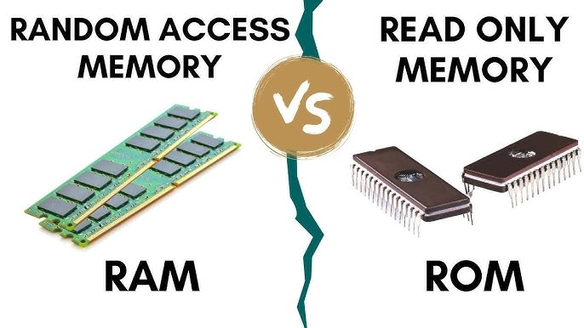

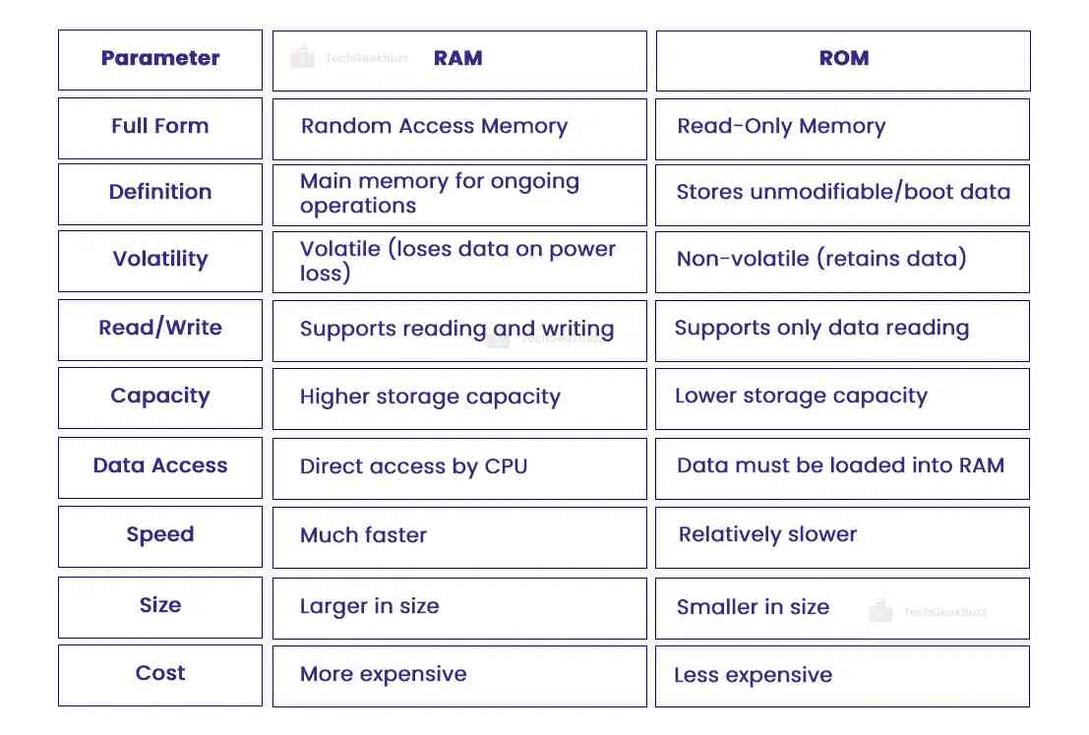

* **3. Display Devices (Monitor)**
* **Hinglish Explanation:**
* Monitor wo device hai jisme computer ka output dikhai deta hai, matlab jo bhi hum type karte hain ya computer process karta hai, wo screen pe dikhta hai. Aajkal ke monitors LED, LCD type ke hote hain jo acchi quality ke images dikhate hain.
* **English Long Definition:**
* A **monitor** is an output device that visually displays the information processed by the computer. Modern monitors use LCD or LED technology to provide clear and high-resolution images.
* **Simple English Definition:**
* Monitor is a screen that shows what the computer is doing.

**4. (Input Devices: Keyboard and Mouse)**

**Hinglish Explanation:**

* **Keyboard** se hum computer ko type karte hain, yani data aur commands dete hain. Isme alphabets, numbers, aur special keys hoti hain.
* **Mouse** ek pointing device hai jisse hum screen par pointer ko control karte hain, click karte hain aur files select karte hain.

**English Long Definition:**

The **keyboard** is an input device used to enter text and commands into the computer. The **mouse** is a pointing device that allows users to interact with the graphical interface by clicking and dragging.

**Simple English Definition:**

Keyboard is used for typing, mouse is used to point and click.

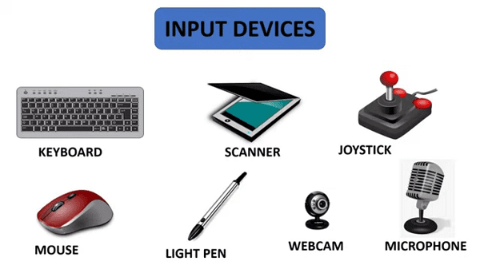

**5. (Storage Devices: HDD and Peripheral Devices)**

**Hinglish Explanation:**

* **HDD (Hard Disk Drive):** Ye computer ki primary storage device hoti hai, jisme hum apne data ko permanently store karte hain. HDD me ek spinning disk hoti hai jo data store karti hai.
* **Peripheral Devices:** Ye wo extra devices hote hain jo computer ke saath connect kiye jate hain, jaise printer, scanner, speakers, webcam, etc. Ye computer ki functionality badhate hain.

**English Long Definition:**

**HDD** is a magnetic storage device used for permanently storing data.

**Peripheral devices** are external hardware components connected to a computer to provide additional functionality, such as printers, scanners, and webcams.

**Simple English Definition:**

HDD stores data permanently. Peripherals are extra devices like printers and scanners.

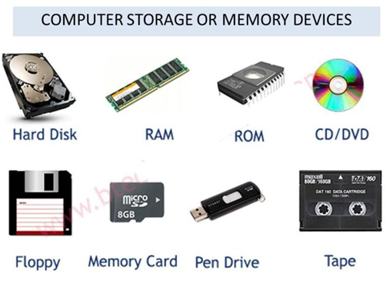

( **UNIT II – Operating System and Commands )**

**1. What is an Operating System?**

* **Short Definition:**

An **Operating System (OS)** is system software that manages computer hardware and software resources and provides services for computer programs.

* **Long Definition:**

An Operating System is a system software that acts as an interface between the user and the computer hardware. It is responsible for managing hardware, software, memory, processes, and all basic functions of the computer. Examples include Windows, Linux, and macOS. The OS also provides a user interface, such as a command line or graphical UI, and handles input/output, file management, and multitasking.

* **WhatsApp Language:**

OS = Boss of Computer   
Jo sab kuch handle karta hai – memory, files, apps, user input.  
Bina OS, computer sirf ek dabba hai.   
Example: Windows, Android, Linux, macOS

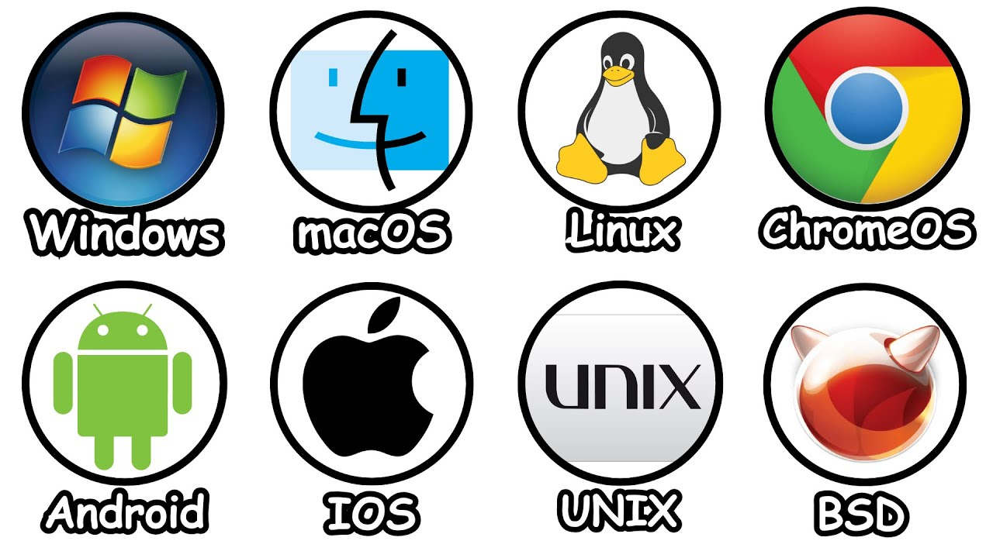

**OS Installation (Linux and MS Windows)**

**Hinglish Explanation:**

Operating System (OS) wo software hota hai jo computer ke hardware aur software ko manage karta hai. OS installation ka matlab hai apne computer me OS ko install karna, jisse computer chal sakta hai. Popular OS me Windows aur Linux shamil hain.

* **Windows Installation:** Ye easy hai, jisme CD ya USB se boot kar ke setup follow karte hain.
* **Linux Installation:** Thoda advance hai, jisme command line aur GUI dono options hote hain. Linux free aur open-source OS hai.

**English Long Definition:**

**Operating System installation** involves setting up software like Windows or Linux on a computer, which manages hardware resources and provides a user interface. Windows installation typically uses a graphical setup wizard, while Linux installation may involve both graphical and command-line methods.

**Simple English Definition:**

Installing OS means putting Windows or Linux software on a computer so it can work.

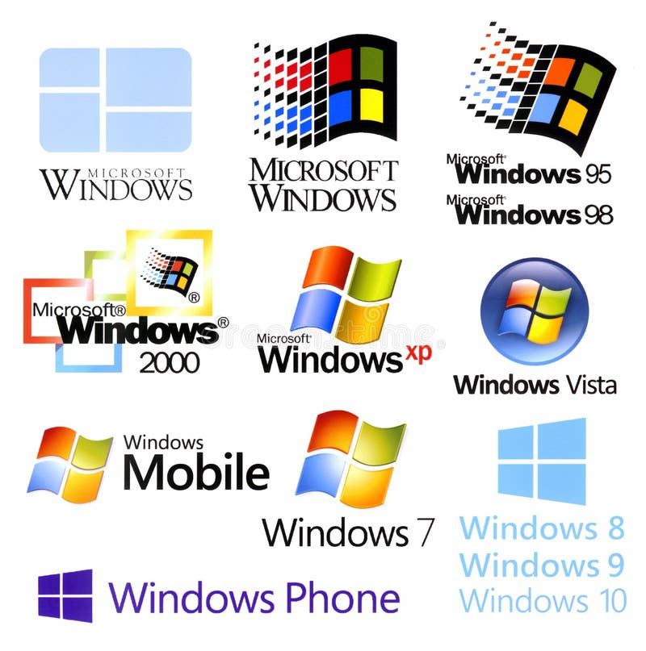

* **Unix Shell and Commands**

**Hinglish Explanation:**

Unix shell ek command-line interface hai jahan users commands type karke system se baat karte hain. Unix shell se hum files create kar sakte hain, move kar sakte hain, delete kar sakte hain aur programs chala sakte hain. Common commands hain: ls (list files), cd (change directory), rm (remove files).

**English Long Definition:**

**Unix Shell** is a command-line interpreter that provides a user interface for accessing the Unix operating system’s services. It allows users to execute commands to manipulate files, directories, and processes.

**Simple English Definition:**

Unix shell is a text-based way to control the computer by typing commands.

**vi Editor**

**Hinglish Explanation:**

vi editor ek popular text editor hai jo Unix/Linux systems me use hota hai. Isme hum files create, edit kar sakte hain directly command line se. vi editor me alag modes hote hain, jaise command mode aur insert mode, jinse hum text ko edit karte hain.

**English Long Definition:**

**vi editor** is a screen-oriented text editor used in Unix and Linux systems. It provides modes for inserting text and issuing commands to edit files efficiently.

**Simple English Definition:**

vi editor ek program hai jisse hum text files banate aur edit karte hain Linux mein.

=========🡺

**OS Examples in Detail🡺**

**Windows OS**

* Versions: Windows 7, 8, 10, 11
* Used in: Personal computers, laptops
* Type: Closed source, GUI based

**macOS**

* Made by: Apple Inc.
* Only works on: Apple computers (MacBook, iMac)
* Known for: Security, performance, UI

**Linux (Ubuntu, Fedora, Kali)**

* Free and open-source
* Developers and students use it
* Secure, command-line powerful

**Android**

* Based on: Linux Kernel
* Used in: 80%+ smartphones worldwide
* Supports: Apps, games, internet, etc.

**iOS**

* Made by: Apple
* Used in: iPhones, iPads
* Fast, secure, smooth UI

**UNIX**

* Multi-user, multitasking OS
* Used in: Servers, networks
* Command-line interface based